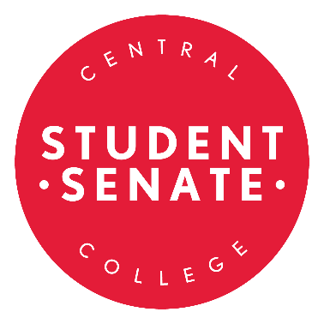

The Student Senate is a key link between the Student Body and the Administration, Faculty and Staff of Central College. The Student Senate serves as a bridge of communication; bringing the entire campus community together. Student Senators are considered fantastic leaders, and they are enthusiastic about their duties and passions at Central College. The responsibility of a Senator is a very rewarding experience. As a Senator, your duties would include, but not be limited to:
1. Attend regular meetings and events (1-5 hour weekly commitment)
2. Sit on one Senate committee and one faculty committee.
3. Distribute funds to clubs and organizations within the Central community
4. Present or initiate legislation and accept, reject, or recommend revision of all proposals
submitted to it.
5. Reserve the right to use any power or procedures stated in the Constitution.
6. Adhere to Robert’s Rules of Order.

In order to run, the applicant must provide a petition with 10 student signatures and a 250-300 word personal statement explaining his/her purpose and qualifications for seeking the position.

Please direct any questions to John Horner at ssenate@central.edu.

Please submit signatures and a printed copy of your personal statement to Student Involvement. (2nd Floor Maytag Student Center). Also, please email your 250-300 word personal statement to (ssenate@central.edu).
Election process:
- Applications are made available on Wednesday September 4th.
- Completed applications due at noon on Friday, September 13th.
- Elections begin at noon on Monday, September 16th and will last through noon on Friday, September 20th.
- After vote tabulations are completed the candidates will be notified whether or not they were elected on Friday, September 20th. Those elected should plan to attend the Student Senate retreats on Sunday, September 22nd and Monday, September 23rd (details to follow), and the first Student Senate meeting at 8:00 p.m. on September 26th.
Please review the following before you begin your campaign:
Election Guidelines:

Candidates must behave in an ethical manner towards other candidates and voters. Candidates shall not hamper or prevent the full and free expression of the will of the voters including acts intended to prevent any eligible person from voting.

Candidates shall be respectful of other candidates and refrain from personal attacks on the candidates or others closely associated with candidates.

Candidates and those campaigning on their behalf are asked to remember Central College’s Code of Conduct and the rules regarding student discourse. Any violations to Student Policies will result in judicial action.

Printing will be available through the Office of Student Involvement, students running for Student Senate will be allowed 5 standard color copies (8.5” x 11”) at the expense of Student Senate. Copies must be made upon approval by student workers in the Office of Student Involvement.

Each candidate shall follow school rules about posting fliers around campus.

If posters are removed over the course of the election, new fliers may be printed to replace posters where others were removed.

No additional materials from the Office of Student Involvement should be used in an individual’s campaign for Student Senate.

Central College associated email lists, such as Blackboard email lists, should not be used to send emails regarding a candidate in the election. Only self-generated email lists can be used.

A candidate should not ask any other individual to send emails on their behalf outside of a campaign manager (if abroad you will be permitted a campaign manager to speak on your behalf).

Candidates shall not use any quid pro quo methods to gain votes. This means there shall be no giving something of value or benefit in order to influence another student in the act of voting for a specific candidate. General handing out of candy, cookies, or other food, in order to generally encourage voter turnout does not constitute a quid pro quo method of gaining votes.

Candidates shall not coerce election help or votes for themselves, including, but not limited to asking for support from faculty or staff who may be in a position of influence/power/authority over students, or have an electronic device provided for voting during campaigns.

Candidates shall be respectful and courteous when campaigning in residence halls and in public areas (i.e. Maytag, Central Market, Roe).

No candidate shall ask for, or receive any campaign contributions from any student or individual.

Any questions regarding campaign ethics and practices, please be directed to Parliamentarian John Horner or Student Senate Advisor Carol Williamson.

By submitting an application, I agree to follow these election guidelines.

Circle Class of Applicant: First Year Second Year Junior Senior
Students supporting _______________________________________
(First) (Last)
as a Central College Student Senator during the 2019/2020 school year:

1. _______________________________ 2. _______________________________

3. _______________________________ 4. _______________________________

5. _______________________________ 6. _______________________________

7. _______________________________ 8. _______________________________

9. _______________________________ 10. ______________________________

By submitting this application, I agree to follow the election guidelines as stated.

Applicant Signature ________________________________

